**Severstal Steel Defect Detection**

**Introduction:**

Steel is one of the most important building materials of modern times. Steel buildings are resistant to natural and man-made wear which has made the material ubiquitous around the world. Serverstal is the Russian Steel producing company, looking for machine learning approach to improve automation, increase efficiency, and maintain high quality in their production. The production process of flat sheet steel is especially delicate. From heating and rolling, to drying and cutting, several machines touch flat steel by the time it’s ready to ship. This project will help engineers improve the algorithm by localizing and classifying surface defects on a steel sheet.

**Problem Statement:**

The objective of this project is to predict the location and type of defects found in steel manufacturing using the images provided. The images are named with a unique ImageId, and our task is to segment each image and classify the defects in the test set.

**Dataset:**

Data is taken from the Kaggle challenge, link: <https://www.kaggle.com/c/severstal-steel-defect-detection/data>. which is around size ~2GB and consists of 18076 images. There are 12568 images in the train set. 5506 images in the test set Of the training 12568 images, only 7095 images have defects, rest have no defects. Each image is of size 1600*256. The location of the defects we given as encoded pixels. We have to decode them using a mask function to get the defect location.

**Data Description:**

Each Image may have no defects, a defect of a single class, or defects of multiple classes (ClassId = [1, 2, 3, 4]). Given a image, our task is to classify the defect and locate the segmentation of the defect. For each image you must segment the defects if it belongs to each of the class (ClassId = [1, 2, 3, 4]).

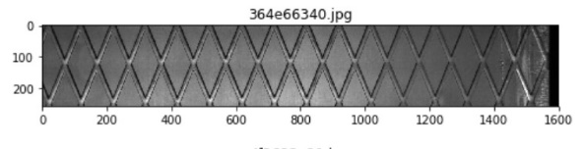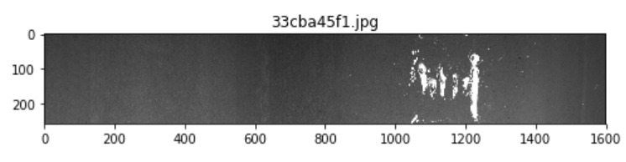

**Fig 1: left image with no defect and right images with defects**

Since all images are in the grey scale just by visually can not identified defects in them. Hence Using Machine learning and Keras Application like CNN, Resent they are classified and Where exactly defect is present is seen by Unet model.

**Task Performed:**

We have performed 4 tasks in this project for classification and object detection:

1. **Exploratory Data Analysis**: Data cleaning finding the defects types findng the
2. **Binary classification problem**: Identify whether an input images has a defect or no defects.
3. **Multi-class Classification problem**: Identify the number of class type of defects an image contains, each image can have up to 4 types of defects corresponding to classes [1,2,3,4]
4. **Object Detection**: For each defect type, identify regions of the image that has this defect. This is an image segmentation problem, where each pixel is labeled as having no defect or a defect of a particular type.

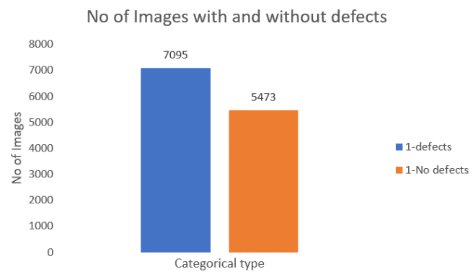**Exploratory Data Analysis:**

We performed EDA, using bar chart we classified images which has defect and with no defects. From the whole dataset 5473 images with no defects were labeled as **0** and7095 images with defects were labeled as **1.** The number of images with and without defects are proportionate and the data seems quite balanced. From the fig 1, we concluded that data is balanced for doing binary classification.

**Fig 2: Binary classification**

Now we will plot the bar graph to see class type of defects each image has, there are 4 types of defects **Type1** defect which conation small seed like scratch or crack on the steel sheet. **Type2** defect which has thin vertical crack on the images. **Type3** multiple vertical line cracks on sheet and Type4 has medium area size defects in images, In the segmentation plot we can see it more clearly the defects.

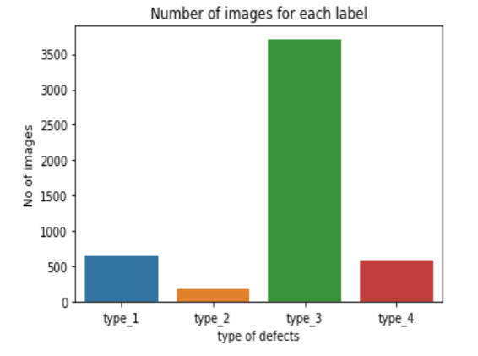Categories of defects – Type1, Type2, Type3, Type4. From that Lot of images with defects belong to Type3. Very few samples for the type2 defects data is very imbalance here. So, to balance the data we tried data augmentation has performed for data augmentation resampling techniques also used and also tried SMOTE method to balance the data. Batch normalization had performed best compared to other methods.

**Fig 3: Multiclass classification**

EDA was also performed to check whether there are multilabel image, some of the images had more than one type of defects in them. Use bar graph these images were also classified.

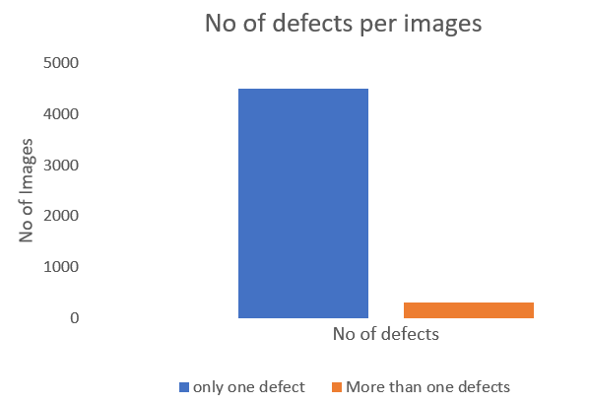

These images were classified as multilabel, since they were very few in number. We removed from the data. Now our data is resized and ready to feed into neural network for binary classification and multi class classification model.

**Fig 4: Multilabel classification**

**EDA conclusion**:

The dataset is imbalanced thus we will use stratified sampling for splitting the dataset into train and validation datasets. This is a multi-label image segmentation problem. As there are around 50% of images with no defects, it is equally important to identify images with no defects. Convert masks to EncodedPixels and filter them as per classification probabilities.

**Segmentation:**

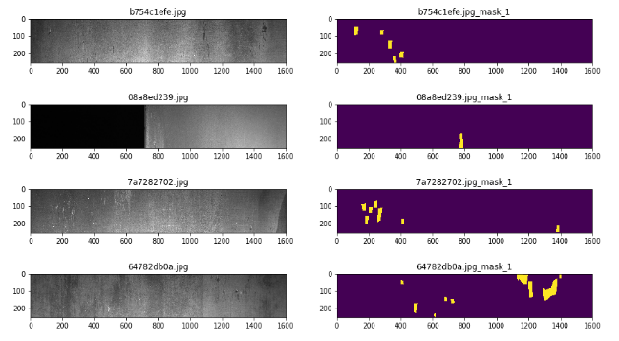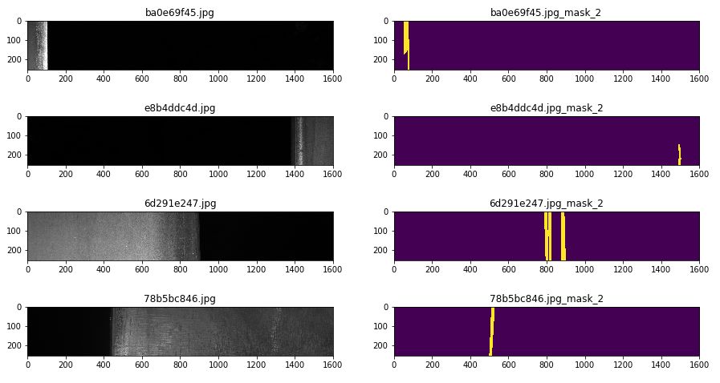

**Fig 5: Type 1 defects Fig 6: Type 2 defects**

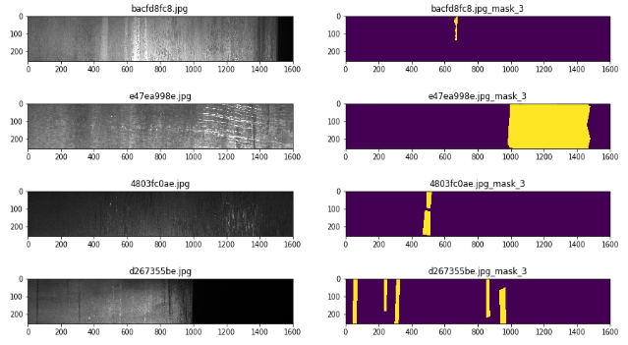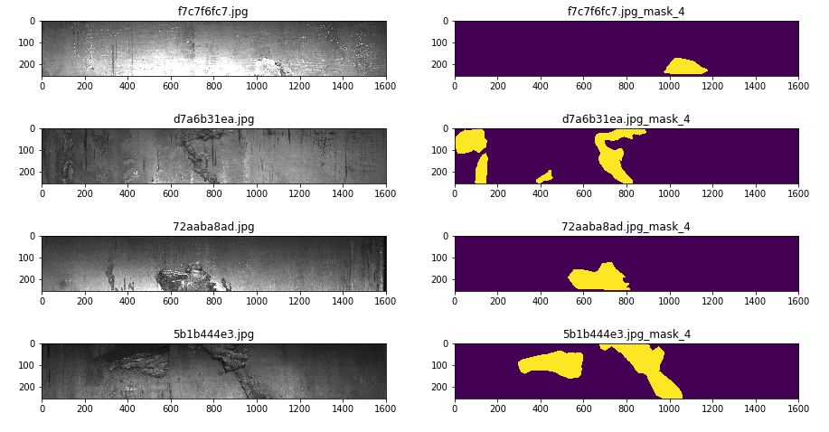

**Fig 7: Type 3 defects Fig 8: Type 4 defects**

**Binary Classification:**

To do the Binary Classification, Convolutional Neural Network (CNN) model has been used, as it outperforms all other models in context of images. The architecture of CNN model has been presented in Fig 9. The CNN model starts with 3x3 convolution, with 36 filters in the first layer followed by 2x2 Max Pooling layer, reducing the image size by half. The image with size of 256 is reduced to size of 128 by Max Pooling layer. In the second layer, again there is convolution layer with 3x3 kernel, with 64 filters and so on. At the end of four layers of convolution and max pooling, the final layer is flattened, and feed to the dense layer. The model summary in details has been presented in Figure 4, showing the number of parameters for each layer.

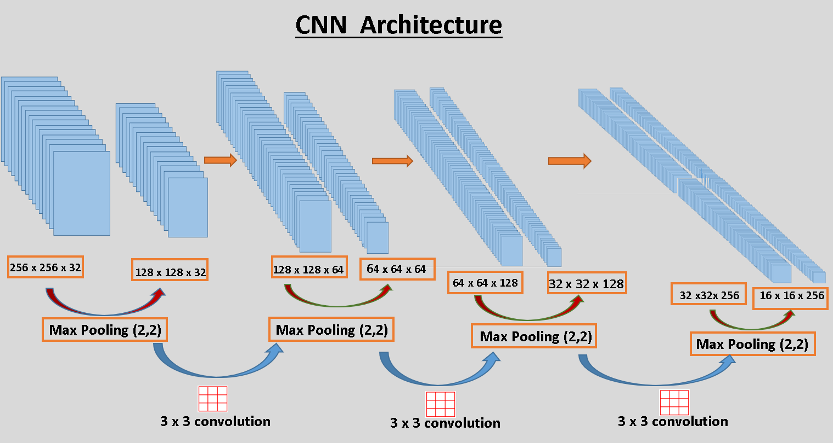

Although the model is small with just four convolution layers and one dense layers, it gives quite good accuracy. In the figure 5 (a) , the loss keeps on decreasing with the increase in number of epochs. The validation accuracy keeps on increasing upto ten epochs, then starts decreasing. The training accuracy keeps on increasing, which was expected with the increase in the number of epochs. The overfitting can be seen here after ten epochs, however a very good accuracy has been achieved till then. The validation accuracy of 85% has been achieved which is quite good. The model can be said to generalizing well.

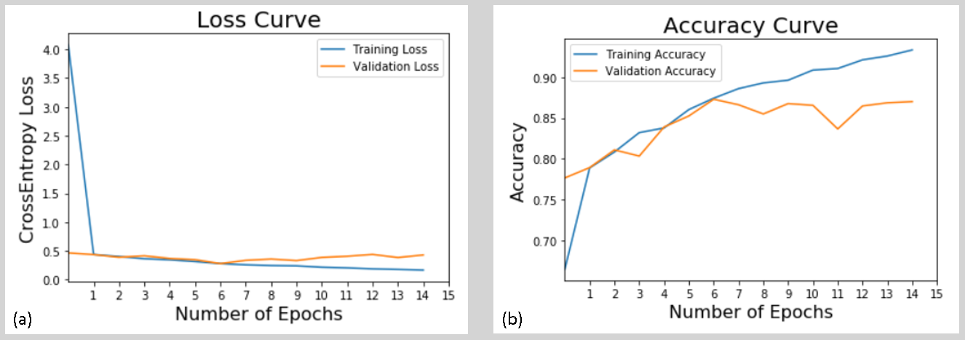

**Confusion Matrix**

|  |  |  |
| --- | --- | --- |
|  | **True No-Defect** | **True Defect** |
| **Predicted No-Defect** | 1039 | 142 |
| **Predicted Defect** | 181 | 1152 |

Table 1 shows the confusion matrix obtained by the model on test-data. It’s working quite well, as it is able to identify most of the examples correctly. However, there are some wrong prediction, but they are quite low in number. For these types of problems of quality insurance, the problem comes when a defected steel is classified as non-defect steel and is sent to the market. This number should be kept as low as possible. In our model, it’s identifying 142 defect cases as non-defect cases. It’s around six percent of total cases used to create the confusion matrix.

**Precision-Recall Matrix**

|  |  |  |
| --- | --- | --- |
|  | **Precision** | **Recall** |
| **No-Defect** | 0.85 | 0.88 |
| **Defect** | 0.89 | 0.86 |

Table 2 shows the precision recall matrix. The prediction precision is quite high around 85% for non-defect examples, and 89% for defect examples. But recall is of more interest, as we wants to see how accurately, it’s able to recall the steel type as defect or non-defect. The recall percentage for non-defect and defect cases are 88% and 86% respectively.

The CNN model is generalizing quite well. It’s able to identify the defect steel with a very good accuracy. However, the performance could be increased with regularization and more tuning the model. For the time being, the model performance is quite well.

**Multi Class Classification**:

In this section we built a multi-class classifier to classify the type steel defect shown on an image. To mitigate the class-imbalance, during training we will augment the images and for every batch augmented we will over sample the minority classes to have better representation. To evaluate the performance of the model, we expect the precision, recall and f1 scores to be similar in training, validation and testing datasets. Class number 3 is approximately 75 percent of the whole dataset. In other words, just by predicting class 3 the model can achieve an accuracy of 75 percent. Therefore, we need the model to generalize among each class as much as possible.

The images were preprocessed into a shape of 64 by 64 to a gray scale, as a way to reduce the number of features. To reduce the memory footprint, to train the model we will use an image generator from Keras. As mentioned above, an additional piece of code was added to balance the image generated during training. To augment the training data, the image generator will flip the image horizontally and vertically, and also tweak the brightness from a range of 02. to 0.8. To ensure reproducibility, the random number generator was seeded at 42.

To reduce overfitting due to the class imbalance, the model was created with several dropouts. After the first convolutional layer we used a batch normalization layer which improved the learning of the algorithm. The following layers are two blocks of convolution, 10 percent spatial dropout and max-pooling layer, then another convolution and a max-pool layer. The classifier has a ten percent dropout with 512 neurons in the first dense layer and 4 neurons in the output layer. This model architecture gives a total of 5,109,060 trainable parameters. Due the image data generator will act randomly, to enhance the learning and avoid learning cycles the optimizer used is stochastic gradient descent. The loss function is categorical entropy and the target metrics is accuracy. The activations functions for the convolutional and the first layer was Relu and SoftMax for the output layer.

Training convolutional models takes time and sometimes after a few epochs it can start overfitting. One strategy we used was to record the best weights after every epoch based on the accuracy of the validation. Additionally, we added early stopping and reduce plateau to monitor the model's learning and stop the process when the model has already learned enough

Initially for every epoch the accuracy of the validation increased while its loss was not stable. After 20 epochs the accuracy of the training and validation plateaus out but the loss in the validation does not show a significant change as in the training set. This trend in training and the confusion matrix and classification report of the trained model shows the model does generalize for class 1, 2 and 3 but it enables to properly classify class 4

|  |  |  |  |
| --- | --- | --- | --- |
| Training Classification Report | Precision (%) | Recall (%) | F1-Score (%) |
| 1 | 68 | 70 | 69 |
| 2 | 80 | 70 | 75 |
| 3 | 89 | 91 | 90 |
| 4 | 47 | 37 | 41 |
| Accuracy |  |  | 83 |
| Macro Avg | 71 | 67 | 69 |
| Weighted Avg | 82 | 83 | 83 |

|  |  |  |  |
| --- | --- | --- | --- |
| Validation Classification Report | Precision (%) | Recall (%) | F1-Score (%) |
| 1 | 43 | 47 | 45 |
| 2 | 50 | 47 | 49 |
| 3 | 84 | 85 | 84 |
| 4 | 12 | 10 | 11 |
| Accuracy |  |  | 74 |
| Macro Avg | 47 | 47 | 47 |
| Weighted Avg | 73 | 74 | 73 |

|  |  |  |  |
| --- | --- | --- | --- |
| Testing Classification Report | Precision (%) | Recall (%) | F1-Score (%) |
| 1 | 54 | 49 | 51 |
| 2 | 48 | 63 | 55 |
| 3 | 84 | 88 | 86 |
| 4 | 23 | 13 | 17 |
| Accuracy |  |  | 76 |
| Macro Avg | 52 | 53 | 52 |
| Weighted Avg | 74 | 76 | 75 |

Training convolutional neural networks with a small unbalanced dataset is not an easy task. After implementing several strategies to build the model, due to the given dataset, the model overfits. Ideally, a larger dataset with more class representation would do the work. Another option would be to try and drop class 4, this might decrease the overfit and improve the validation scores.